**The Timeline of Unfolding Creation: Linking the Doctrine of Creation and the Evolution of the Cosmos**

*Goals:*

* *To create several timelines to scale modeling the relative position of important events in cosmological time, evolution, and modern revelation.*
* *Articulate the proper understanding of the Catholic doctrine of creation.*
* *Recognize the ways in which revelation occurs in various moments in evolutionary and human history.*
* *Understand the difference between Natural and Divine Revelation.*
* *Understand and articulate that all of creation (including cosmological history) is “Christ-centered,” i.e. that Christ/salvation is the ultimate end (purpose/goal) of the entirety of creation.*

*Background Information*

God’s created act did not happen once upon a time or at any one point in time or space. Rather God’s creative act is a single, eternal, timeless act wherein God wills it to all to be.

Since God is eternal, his creative act is itself timeless. Creation with time means every time is the moment of creation. All things are being brought into being right now. You are a human being who is being created by God with every heartbeat.

However, our universe has a first moment- which science identifies as the Big Bang. Because, unlike God, we are temporal beings we are experiencing the unfolding of creation across the millenia. The record of the unfolding creation is unveiled through scientific analysis of the cosmos, the geological record, the fossil record, and human history itself. This natural revelation compliments Divine Revelation in proclaiming the creator to the creation.

*Pre-Activity Questions*

1. What is meant by the history of creation? Give an example to support your answer.
2. One characteristic attributed to God is creativity. In what ways is his creativity demonstrated to us?
3. What is the *logos*?
4. Where does the *logos* appear in creation?

*Procedure:*

We will complete this activity in five parts – each part will “zoom in” on one particularly interesting timeline. For each part, you will be given several important events occurring in that time frame. C**alculate the corresponding distance on a football field that each event represents** – this goes in the “Distance” column. We will then physically demonstrate the time differences for each event by spacing ourselves out on a football field.

*Some of these timelines may be assigned as homework. Using the same technique we did in class, determine the distances for the events listed. Using the blank football field(s) on the page(s) provided, label where people would stand to represent the various events in human evolution.*

***Part 1: Cosmological Timeline***

**For this part, 1 yard = 150 million years**

(BTW, this means 1 inch is 4.2 million years)

|  |  |  |
| --- | --- | --- |
| **Event** | **Approximate Age** | **Distance (yards)** |
| Big Bang (First revelation of the *Logos*) | 13.8 billion years ago | 92 |
| First stars and galaxies form | 13.3 billion years ago | 88.67 |
| Milky Way galaxy forms | 8.5 billion years ago | 56.67 |
| Our solar system forms | 4.6 billion years ago | 30.67 |
| The moon forms from an asteroid crashing into Earth | 4.5 billion years ago | 30 |
| Life appears on Earth | 3.5 billion years ago | 23.33 |
| First multicellular animals appear | 900 million years ago | 6 |
| Tiktaalik climbs out of the ocean (first land vertebrate) | 375 million years ago | 2.5 |
| Giant meteorite kills off the dinosaurs | 65 million years ago | 0.43 |
| Jesus Christ is born (*Logos* made flesh) | 2000 years ago | 0.000013 (0.0117 mm) |

**\*\*\*\*\*\*\*Which of the above events are within the first 10 yards of the football field from the TODAY end zone? Circle them.**

***Part 2: Geologic Timeline***

**For this part, 1 yard = 50 million years**

(BTW, this means 1 inch is 1.4 million years)

|  |  |  |
| --- | --- | --- |
| **Event** | **Approximate Age** | **Distance (yards)** |
| Formation of the Earth | 4.6 billion years ago | 92 |
| First single-celled organism appear | 3.5 billion years ago | 70 |
| The “Oxygen Revolution;” oxygen builds up in the atmosphere | 2.3 billion years ago | 46 |
| First multicellular animals appear | 900 million years ago | 18 |
| First vertebrates appear | 535 million years ago | 10.7 |
| Tiktaalik climbs out of the ocean (first land animal) | 375 million years ago | 7.5 |
| The Supercontinent Pangea Forms | 280 million years ago | 5.6 |
| Giant meteorite kills off the dinosaurs | 65 million years ago | 1.3 |
| First “humans” appear | 5 million years ago | 0.1 |
| Jesus Christ is born (*Logos* made flesh) | 2000 years ago | 0.00004 (0.036 mm) |

**\*\*\*\*\*\*\*Which of the above events are within the first 10 yards of the football field from the TODAY end zone? Circle them.**

***Part 3: Evolutionary Timeline***

**For this part, 1 yard = 5 million years**

(BTW, this means 1 inch is 280,000 years)

|  |  |  |
| --- | --- | --- |
| **Event** | **Approximate Age** | **Distance (yards)** |
| First known fish | 535 million years ago | 107 |
| First known amphibian | 375 million years ago | 75 |
| First known reptile | 325 million years ago | 65 |
| First dinosaurs appear | 230 million years ago | 46 |
| First known mammal | 200 million years ago | 40 |
| First known bird | 160 million years ago | 32 |
| Giant meteorite kills off the dinosaurs | 65 million years ago | 13 |
| First “humans” appear | 5 million years ago | 1 |
| *Homo sapiens* appear | 200,000 years ago | 0.04 |
| Jesus Christ is born (*Logos* made flesh) | 2000 years ago | 0.0004 (0.36mm) |

**\*\*\*\*\*\*\*Which of the above events are within the first 10 yards of the football field from the TODAY end zone? Circle them.**

***Part 4: Human Timeline***

**For this part, 1 yard = 50,000 years**

(BTW, this means 1 inch is 1,500 years)

|  |  |  |
| --- | --- | --- |
| **Event** | **Approximate Age** | **Distance (yards)** |
| First “humans” appear | 5 million years ago | 100 |
| Lucy, or *Australopithecus afarensis* | 3.2 million years ago | 64 |
| *Homo habilis* (first to use tools) | 2.5 million years ago | 50 |
| Humans migrate out of Africa | 1.5 million years ago | 30 |
| *Homo Heidelbergensis* lives in Africa and Europe | 600,000 years ago | 12 |
| *Homo Neanderthalensis* appear | 230,000 years ago | 4.6 |
| *Homo sapiens* appear | 200,000 years ago | 4 |
| Evidence of speech and symbolism | 150,000 years ago | 3 |
| Oldest cave art | 33,000 years ago | 0.66 |
| Jesus Christ is born (Logos made flesh) | 2000 years ago | 0.04 (1.44 inches) |

**\*\*\*\*\*\*\*Which of the above events are within the first 10 yards of the football field from the TODAY end zone? Circle them.**

***Part 5: Modern Revelation Timeline***

**For this part, 1 yard = 50 years**

(BTW, this means 1 inch is 1.4 years)

|  |  |  |
| --- | --- | --- |
| **Event** | **Approximate Age** | **Distance (yards)** |
| Oral Transmission of Genesis Story | 3000 BC (5000 years ago) | 100 |
| Abraham is born | 2000 BC (4000 years ago) | 80 |
| Moses is born | 1500 BC (3500 years ago) | 70 |
| Jesus Christ is born (*Logos* made flesh) | 5 AD (2000 years ago) | 40 |
| Edict of Milan (Legalization of Christianity) | 313 AD (**1708** years ago) | 34.16 |
| Opening of Council of Trent | 1545 AD (**476** years ago) | 9.52 |
| Creation of the modern Gregorian Calendar | 1582 AD (**439** years ago) | 8.78 |
| Discovery of Quantum Physics | 1900 (**121** years ago) | 2.42 |
| Big Bang Theory Proposed | 1930 (**91** years ago) | 1.82 |
| *Humani Generis* | 1950 (**71** years ago) | 1.42 |
| *Gaudium et Spes*  (Second Vatican Council) | 1965 (**56** years ago) | 1.12 |
| *Fides et Ratio* | 1998 (**23** years ago) | 0.46 |

**\*\*\*\*\*\*\*Which of the above events are within the first 10 yards of the football field from the TODAY end zone? Circle them.**

Use this page to diagram the position of events on any timelines assigned as homework. Label the bottom end zone with the starting point of the corresponding timeline.

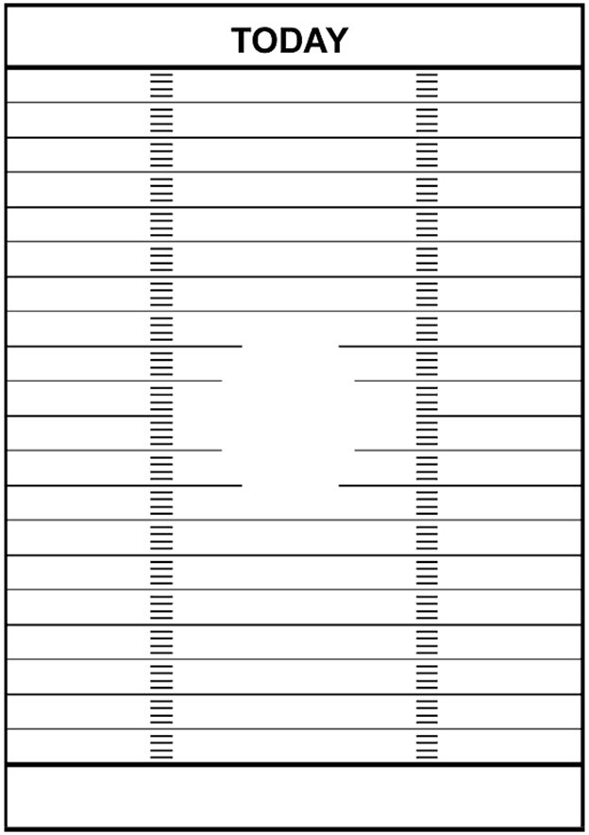

*Post-Activity Discussion Questions:*

1. What is the temporal relationship between significant cosmological events, milestones of human evolution, and Theological events?
2. How does God reveal Himself throughout the history of creation?
3. How does the evolving universe relate to the creative activity of God?
4. What role does Christ play as both the logos and a historical figure?